Lab: Setting up the endpoint
Goal: Understanding the basic concepts that make up and endpoint

ASP.NET Core Empty Template
First, we are going to create a new project to organize our code in.
We select the empty project, because this allows us to build up an API project from scratch, adding components along the way and understanding why they are needed.
Steps:
- Open Visual Studio and create a new project
- Select the template “ASP.NET Core Empty” for the C# language
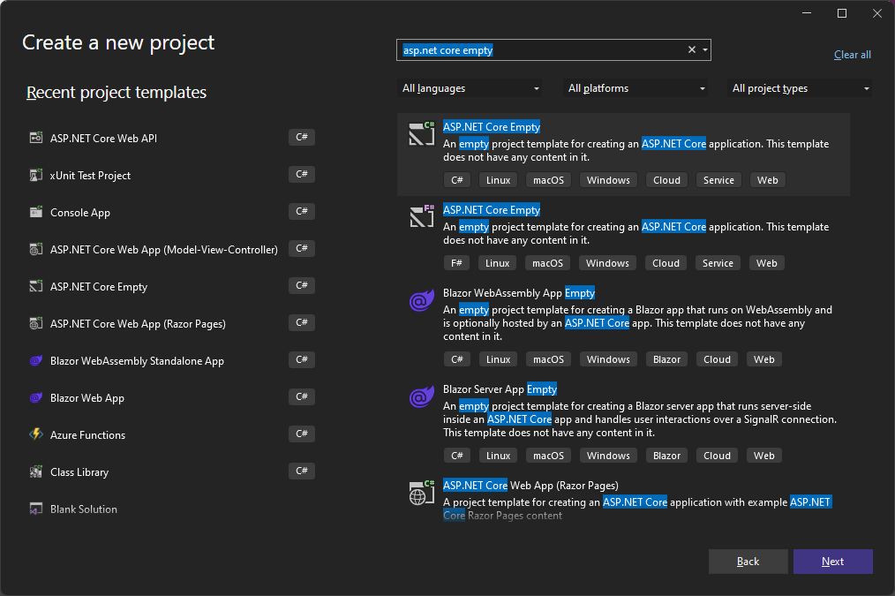
- Provide a name, e.g. “PieShopApi”
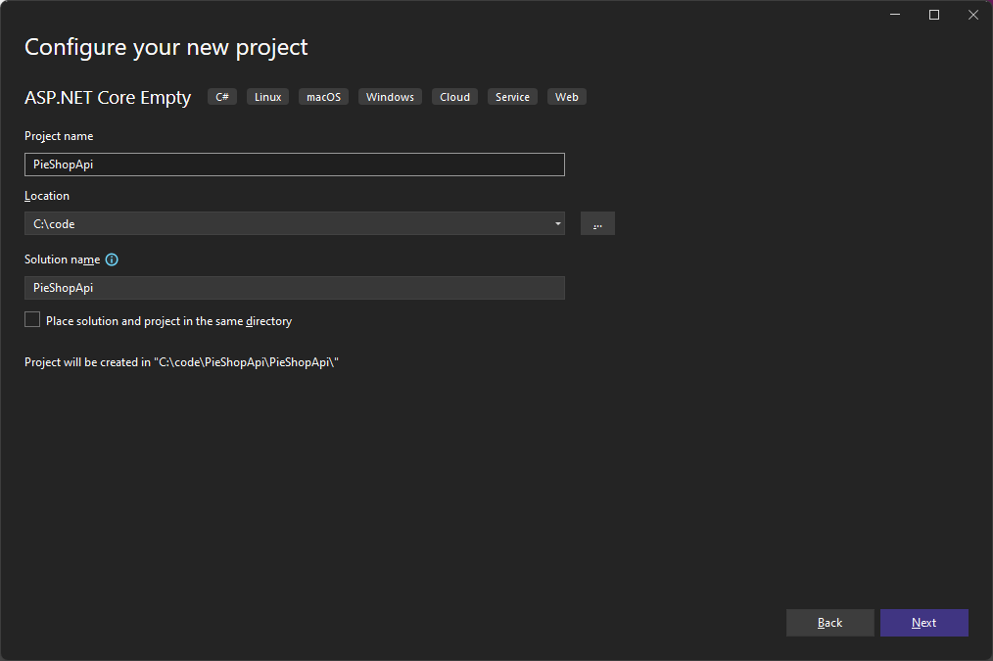
- Make sure the Framework is set to “.NET 8.0 (Long Term Support)”
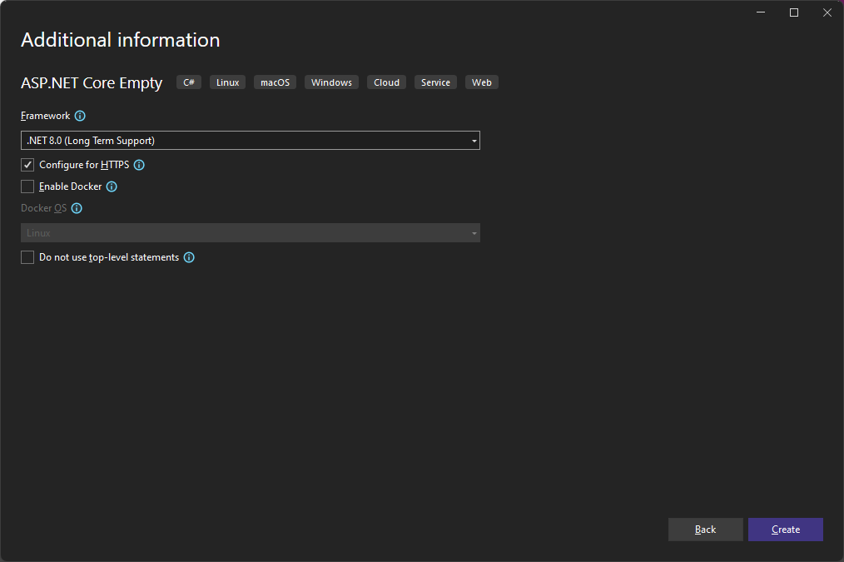
- Click Create
- Open the Solution Explorer (View Solution Explorer), and verify the project structure
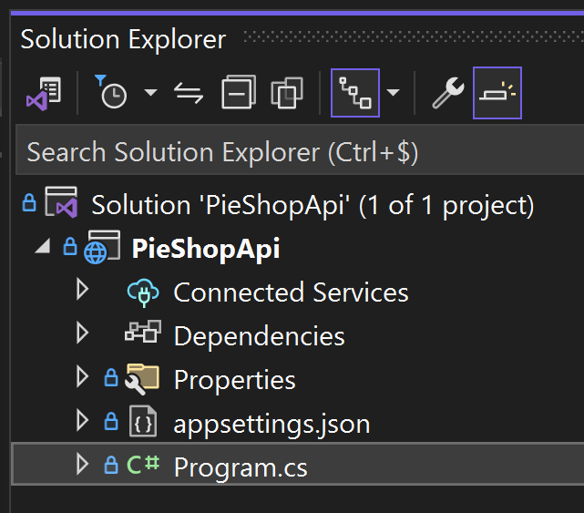

Add Controller support
In this part, we’re going to enable support for Controller based APIs.
This is done in the program.cs file, which is the entry point for the application.
As we’ve unchecked the option “Do not use top-level statements” during project creation, there is no program class or main method in our program.cs file.
Know that this is a compiler trick; the class and main method are generated by the compiler.
The program.cs file contains the WebApplicationBuilder, which is responsible for hosting our ASP.NET Core application.
It allows us to register the services we need for our application and to configure the ASP.NET Core application pipeline.
Steps:
- Open the Program.cs file
- Remove the line containing “Hello World”

app.MapGet("/", () => "Hello World!");

- Add Controller support to our service container
var builder = WebApplication.CreateBuilder(args);

builder.Services.AddControllers();

- Tell the application search for controllers and register the endpoints
var app = builder.Build();

app.MapControllers();

app.Run();
- The complete programs.cs file should look like this:
var builder = WebApplication.CreateBuilder(args);

builder.Services.AddControllers();

var app = builder.Build();

app.MapControllers();

app.Run();

Create the controller
In this part we’re going to create a “controller”. The controller contains the endpoint logic.
Steps:
- Add a folder named “Controllers” to our project
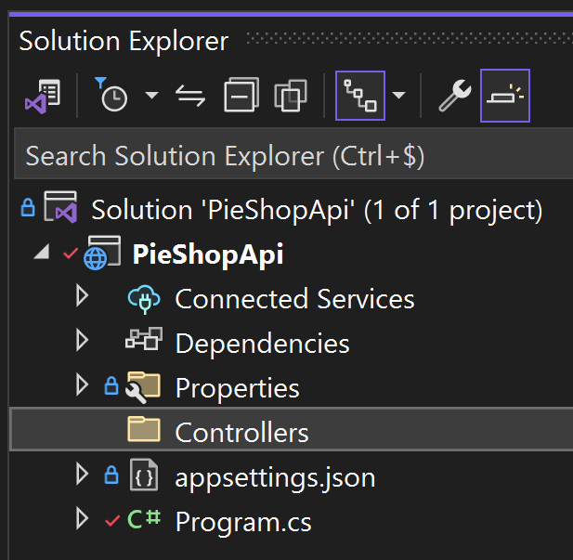
- Add a new class to the “Controllers” folder named “PiesController.cs”
(Right click the Controllers folder Add Class…)
- To tell ASP.NET Core that this is an API controller, we make the following code changes to our class:
  - Add a using statement for the namespace “Microsoft.AspNetCore.Mvc”
  - Inherit from ControllerBase
  - Add the [ApiController] attribute
  - Add a [Route(“pies”)] attribute
using Microsoft.AspNetCore.Mvc;

namespace PieShopApi.Controllers
{
[ApiController]
[Route("pies")]
public class PiesController: ControllerBase
{
}
}
- Add a method to return pies inside the class
[HttpGet]
public JsonResult GetPies()
{
var pies = new[] { "Apple Pie", "Blueberry Pie", "Cheese Cake" };

return new JsonResult(pies);
}
- Run the application (F5) and navigate to https://localhost:7043/pies
(note that your port number might be different)
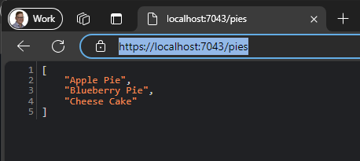

Create the Model
In the previous part, we returned a simple list of names for pies. In this part, we’re going to start modeling our Pie object, so we can add information to them and retrieve them individually.
Steps:
- Add a folder named “Models” to the project
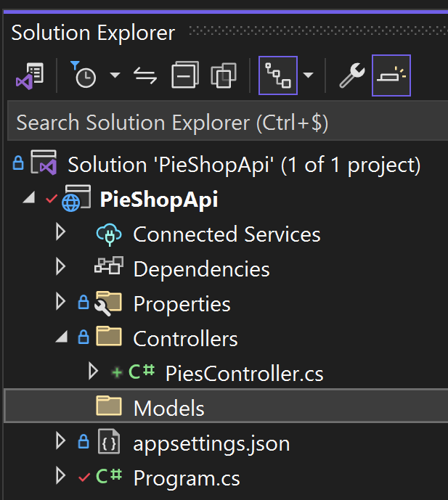
- Add a class named “Pie.cs” to the “Models” folder.
- Add properties for Id (type int), Name (type string) and Description (type string)
public class Pie
{
public int Id { get; set; }
public required string Name { get; set; }
public required string Description { get; set; }
}

Use the model in our controller
Let’s use the model to return a list of Pie objects, instead of a list of name.
Steps:
- Change the GetPies method to return a list of (hard coded) Pies
Notice the [HttpGet] attribute, which tells ASP.NET Core this method accepts HTTP GET requests.
[HttpGet]
public JsonResult GetPies()
{
var pies = new List<Pie>
{
new Pie { Id = 1, Name = "Apple Pie", Description = "Our famous apple pies!" },
new Pie { Id = 2, Name = "Blueberry Pie", Description = "You'll love our blueberry pies!" },
new Pie { Id = 3, Name = "Cherry Pie", Description = "Our cherry pies are the best!" }
};

return new JsonResult(pies);
}
- Run the application (F5) and see the result
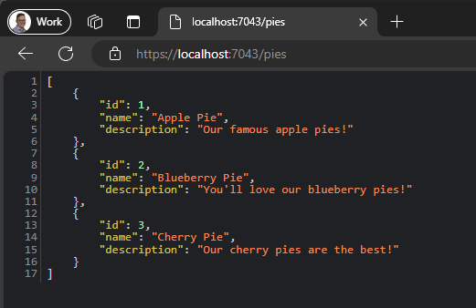

Testing our API with a .http file
.http files are text based files, we can use to test our API. They are added to the project and can be versioned alongside the rest of your code.
Steps:
- Open the Endpoints Explorer (View Other Windows Endpoints Explorer)
and verify it has discovered the “GET” method to the route “/pies” we created earlier
If not, click the refresh icon on the top left of the Endpoints Explorer
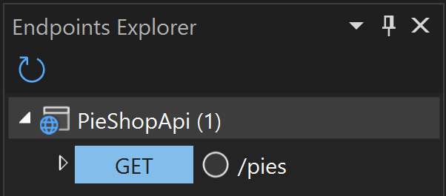
- Right click the “GET” endpoint and select “Generate Request”
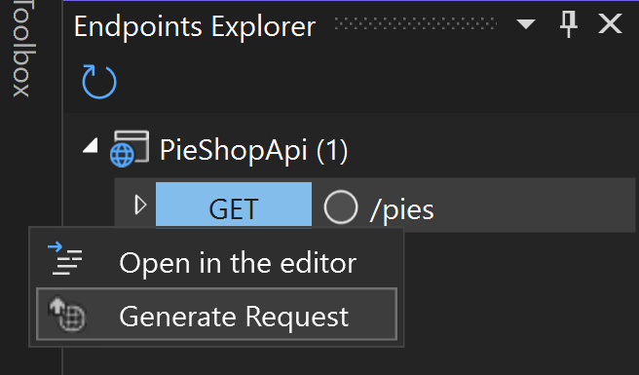
- A new file is added to the project called “PieShopApi.http”
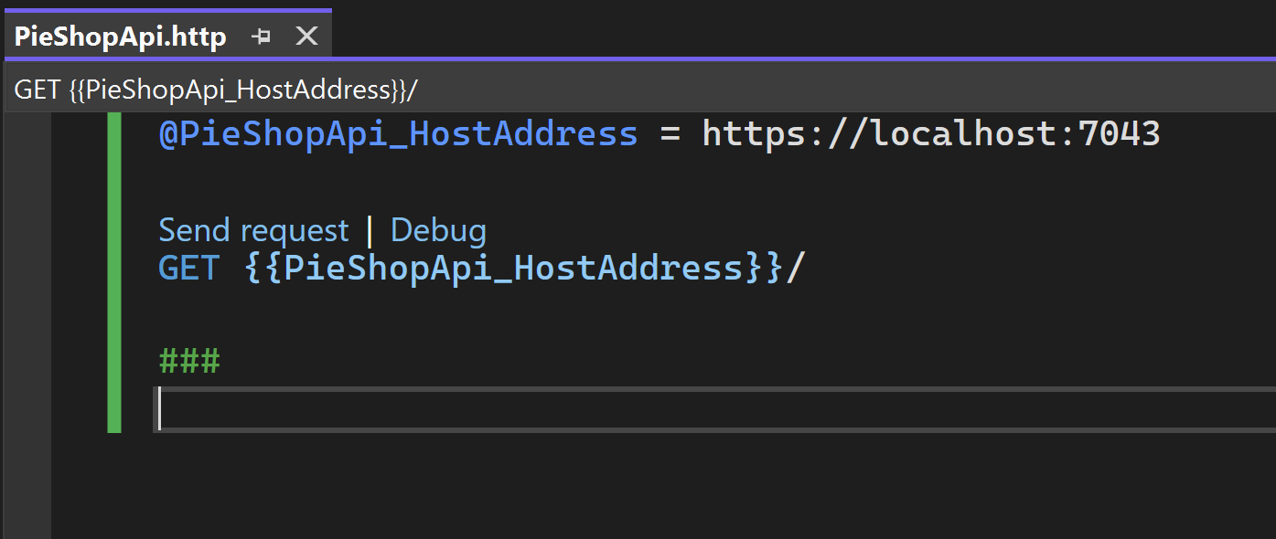
- Run the application (F5)
- In the “PieShopApi.http” file, click on “Send request” above the Get method and verify the result
